ALLEN CHIROPRACTIC, PC,
30012 Ivy Glenn Dr. Suite 170, Laguna Niguel, CA 92677
neuronaut@cox.net • www.allenchiropracticpc.com
(949) 855-9629

Michael D. Allen, DC, NMD (Ret.)
Functional Neurologist
Curriculum Vitae
January 2022

IN BRIEF:

WHO
MICHAEL D. ALLEN, DC, NMD (Ret.)
President, Allen Chiropractic, PC

PROFESSION

Doctor of Chiropractic
Doctor of Naturopathic Medicine
Functional Neurologist

WHERE
Private Practice:
Allen Chiropractic, PC
30012 Ivy Glenn Drive
Suite 170
Laguna Niguel, CA 92677

PUBLICATIONS
What Your Brain Might Say if It Could Speak (2013) and
Receptor Based Solutions™; Functional Neurology Every Doctor Should Know (2014)

BIG PICTURE
Internationally Recognized with almost 50 Years of Private Clinical Experience
Michael D. Allen, DC, NMD (Ret.), DIBAK, DABCN, FACFN (949) 855-9629

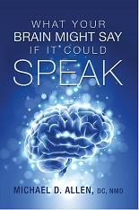
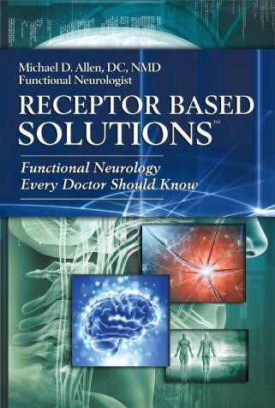
Professional Profile
- Author of: What Your Brain Might Say if It Could Speak (2013; HealthBuilderS® Publishing)
- Author of: Receptor Based Solutions™; Functional Neurology
Every Doctor Should Know. (2014; HealthBuilderS® Publishing)
- Founder and Healthcare Director of Allen Chiropractic, PC, in Laguna Niguel, CA, serving the people of Southern California since 1977.
- Founder of HealthBuilderS® Professional Coaching, the educational division of Allen Chiropractic, PC
- Licensed as a Doctor of Chiropractic (DC) in California, 1977 (Los Angeles College of Chiropractic, Glendale, California)
- Licensed as a Naturopathic Medical Doctor (NMD) in Arizona,
1977 (Arizona Naturopathic Physicians Medical Board)
- Diplomate of the International Board of Applied Kinesiology (DIBAK), 1981
- Diplomate in American Academy of Pain Management
(DAAPM), 1988
- Diplomate in Chiropractic Neurology (DABCN), 1993
- Fellowship in Functional Neurology (FACFN), 2009, specializing in the treatment of functional neurological conditions
- Diplomate in Integrative Medicine (DAAIM), 2015
- Diplomate in Clinical Nutrition (DCBCN), 2015

Professional Accomplishments
An Educator
- Dr. Allen’s clinical and professional expertise has earned him international recognition as an author and teacher in tens of countries on four different continents.
- He has published dozens of papers on his original clinical research in The Proceedings of the International College of Applied Kinesiology.
- Dr Allen developed The New Mother's Program of pre- and post-natal vitamins for an internationally recognized and professionally oriented vitamin company.
- Dr. Allen has experience treating all types of patients from infants to adults, including Professional, Olympic and World-Class Athletes. He has successfully treated professional baseball, hockey, football, tennis, wrestling, boxing, swimming, and weightlifting champions. He also had extensive experience treating vestibular and movement disorders. Dr. Allen has a remarkable passion for people with learning disabilities, having taken extensive training in their unique circumstances.

Professional Experience • He has served as the:
- Vice-Chairman of the USA Chapter of the International College of Applied Kinesiology (ICAK), 1995-1999
- Secretary of the USA Chapter of the International College of Applied Kinesiology (ICAK), 1983-1985
- Member-at-Large of the USA Chapter of the International College of Applied Kinesiology (ICAK), 1998-2008.
- He has served the International Council of the ICAK as its:
  - President, 2001-2003
  - Vice-President, 2003-2008
  - USA Member-at-Large, 1998-2008
  - Chairman, Bylaws Committee, 1998-2008
  - He has served the ICAK’s International Board of Examiners as its neurology consultant (1995-2006).

Special Recognition and Awards
- Dr. Allen has been the Neurology Editor for the International Journal of Applied Kinesiology and Kinesiologic Medicine, 1998-2004.
- Awarded the Key to the City of New Orleans as an Honorary Citizen, 1986
- He is an Honorary Member of the German Medical Society for Applied Kinesiology (DÄGAK), 1998
- Retired Member of the esteemed International Chiropractic Knights of the Round Table, 1984-2009.
- Dr. Allen has twice applied to NASA to be a Mission Specialist onboard the Space Shuttle.

 | International classes held by/for  Dr. Allen |  | 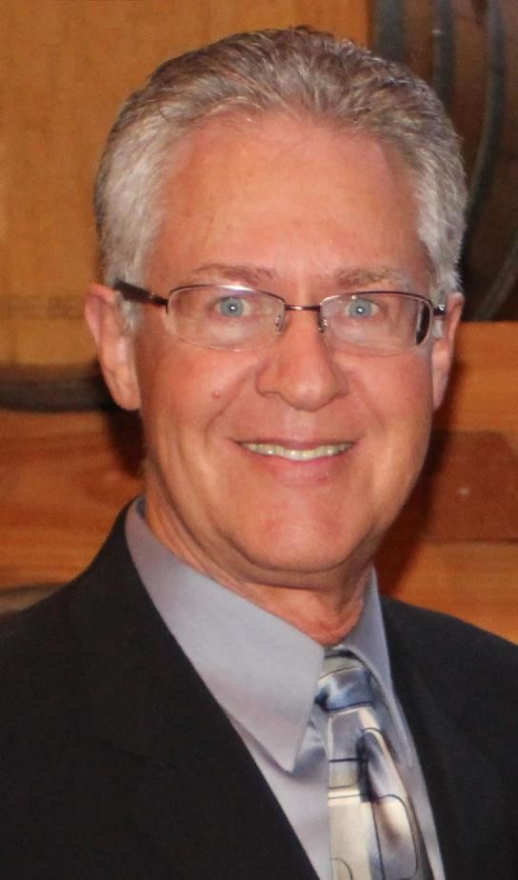
 | Country | Year
 | Australia | ’98, ’01, ’07, ‘19
 | Austria | ‘06
 | Belgium | ‘08
 | Canada | ’05, ’12, ‘16
 | Canary Islands | ‘01
 | England | ’02, ‘06, ‘08
 | Germany | ’02, ‘06
 | Ireland | ‘15
 | Italy | ’91, ’99, ’03, ’18, ‘19
 | South Korea | ‘21
 | Mexico | ‘96
 | New Zealand | ‘08
 | Nova Scotia | ‘15
 | Russia | ’09, ‘10
 | Spain | ‘04
 | Switzerland | ‘17
References
References are available upon request.
